|  |
| --- |
| American Video Game Company |
| Customer Relations Management System Proposal |
| Business Requirements Analysis |

|  |
| --- |
| Toni Fields  4-4-2020  [Version 1.0] |

Contents

A.2.1 Introduction 4

A.1. Purpose Statement 4

A.2. Overview of the Problem 4

A.3. Goals and Objectives 4

A.4. Prerequisites 4

A.5. Scope 5

A.6. Environment 5

B.2.1 Requirements 6

B.1. Business Requirements 6

B.2. User Requirements 6

B.3. Functional Requirements 7

B.4. Non-Functional Requirements 7

C.2.1 Software Development Methodology 8

C.1. Advantages of the Waterfall Method 8

C.2. Disadvantages of the Waterfall Method 8

C.3. Advantages of the Agile Method 8

C.4. Disadvantages of the Agile Method 8

C.5. Best Suited 9

D.2.1 Design 10

D.1. UML Use Case Diagram 10

D.2. Graphical User Interface 11

E.2.1 Testing 12

E.1. Quote & Order Component Testing 12

E.1.1. Quote to Order Placement Conversion Test 12

Functional Testing 12

E.2. Permissions Testing 13

E.2.1. Role-Based Permissions Testing 13

Functional Testing 13

E.3. Communications Testing 14

E.3.1. Communication-Triggered Ticket Event Testing 14

Functional Testing 14

F.2.1 Sources 16

# Introduction

A Customer Relations Management System, or a CRM, is a technological tool that is used for managing a company’s relationships and interactions with its customers. A CRM’s primary focus is on improving business relationships. In order to facilitate these relationships within the American Video Game Company, we will provide a CRM software solution that will facilitate the continued growth of the American Video Games Company.

# PUrpose Statement

This document contains a proposal for a CRM software solution that contains the requirements, the software development cycle model used , the use cases, the design, and the test plans, among other details, that reflect American Video Game Company’s visions and objectives.

# Overview of THE PROBLEM

The current system lacks scalability, unification, and configurability, using spreadsheet and database management software to manage and maintain customer contacts, to track sales performance, to manage activity scheduling, to manage reporting, and to control access to features of the system. The current system is not sufficient for the company’s continued growth.

# Goals and Objectives

The objective is to provide the American Video Games Company with a satisfactory CRM software solution that will meet their current and future business needs. This software solution will provide:

● Scalability ● Reliability ● Functionality ● Performance ● Usability ● Security

The goal is to provide an internally hosted custom-designed CRM with an off-site backup system as part of the company’s business contingency plan with the details to be described herein.

# Prerequisites

These necessary tasks need to be implemented prior to the design, development, and implementation of the project proposed in this document.

|  |  |  |  |
| --- | --- | --- | --- |
| Number | Prerequisite | Description | Completion Date |
| 1 | YES | CRM Requirements Document – Requirements should be clear, unambiguous, consistent, prioritized, and verifiable. This is used to guide development and is used to verify the application’s functionality in later stages. | 4/4/2020 |
| 2 | YES | Project Requirements Authorization – This needs approval by the project manager or another authorized individual(s) to validate that requirements and expectations are understood by all parties. | 4/11/2020 |
| 3 | YES | Proposed Project Budget Authorization – The proposed cost needs to be clearly defined to build trust and establish commitment between the parties in this transaction. Management or another authorized individual(s) need to sign and approve this document. | 4/15/2020 |

# Scope

The custom-designed CRM will provide database functionalities for stakeholders, businesses, and contacts, a contact management system, a sales tracking system, a contract processing system, a customer portal, and a reporting system that will accommodate an increasing amount of users and a peak load average of 500 users at a time. It will only cover user access permissions, but it will not provide a network intrusion detection system nor any such security system to assist in security. It won’t fully integrate every existing system in use, namely a data backup server/system. It cannot fully guarantee that performance objectives will be fully met, as in the instance of a major catastrophe that disrupts performance.

# Environment

The custom-designed CRM will provide support for PCs and Macs that are using various operating systems and browsers, which include the last Chrome/Chromium, latest Firefox, Internet Explorer 9 and above, Safari 6.0, iOS7 Safari, iOS7 third party browsers (Chrome and Firefox), Android 4.0 Chrome, mobiles, and tablets.

# Requirements

The American Video Games Company is in need of a new Customer Relations Management System to incorporate its continuous growth. The company is currently implementing spreadsheet and database management software and other manual methods to handle its business data. The company requires the ability to archive information for historical records, track user activity for auditing and processing, track and manage user activities for records and workflow concerns,

# Business Requirements

System must accommodate at least 2,000 users and during peak times, it must be able to handle at least 500 users at a time. The number of users is expected to increase in the future, and the CRM should be scalable to accommodate this growth. Other requirements are:

● Consolidate client and customer contact information and other sensitive business info

● Reports company activities and interactions with contacts

● Incorporate role-based access controls and permissions for internal and remote users

● Manage permissions

● Enable access to 3rd party marketing contractors

● Track and manage company activities and sales

● Integrate with other internal company systems to allow data sharing

● Be scalable, secure and user-friendly

● Have a clear plan to implement future updates and development

● Have a clear maintenance and support structure

● Have flexibility to allow future integration without reliance on a single team or company

● Have a clearly defined licensing model and ownership rights in all custom development

● Implement the company’s existing internal infrastructure or have a justifiable alternate solution

● All data collected and stored must be done so in accordance with best practices and the law

● All data must be stored, accessed, processed, or analyzed in the U.S., unless management approves

# User Requirements

User requirements are concerned with the CRM’s use by end users. The CRM must include user interfaces to interact with the various parts of the system, must give members of sales teams the ability to track sales, must generate and track quotes and contracts, must allow competitive analyses, and must implement an order management system. The CRM must also implement sales tracking and use systems to manage user activity and user opportunities.

In order to meet these requirements, the CRM software will implement many user interfaces that will allow users to edit their contact information, search for data, format data, query data, and export data. The CRM software will also include order management functionality through the use of a customer portal. Contractors will also have limited access to the CRM software for contracting processes. Sales teams will enter sales information into the CRM and have access to this information through a sales tracking system within the CRM. Activity management and opportunity management functionalities will be implemented by utilizing MS Outlook in a ticketing system used to track workflow for activities and a user interface allowing input for both systems will be used.

# Functional Requirements

Functional requirements are concerned with the CRM’s desired capabilities. The CRM must allow archiving of protected historical records, must maintain versions of records for auditing, roll-back, and workflow, must record user activity for auditing and processing, must allow “soft” and “hard” deletion for authorized users, must use user permissions to control workflow, data access, and editorial control, and must integrate with the currently implemented active directory server.

In order to meet these requirements, the CRM software will allow management to have access to setting access permissions for only those users that are authorized to access certain data and also to users that are authorized to handle deletion of data. The database management system of the CRM will archive and automatically generate backups of historical data and records on regular intervals. The CRM will also ensure that the active directory server that is in use will be incorporated into its system.

# NonFunctional Requirements

Nonfunctional requirements are concerned with the quality of the CRM’s behavior or the constraints placed on it during its execution. The CRM must accommodate over 2,000 users and support at least 500 users during peak usage times.

User access controls and permissions are the only security measures that the CRM will employ. The CRM will have built-in functionality to allow performance testing in order to support performance requirements.

# SOFTWARE DEVELOPMENT METHODOLOGY

Two software development methodologies that are recommended for the American Video Games Company are the Waterfall method or the Agile method. The Waterfall methodology, which is also known as the Linear Sequential Life Cycle Model, progresses in a sequential order. The product development team only moves to the next phase of development or testing once the previous phase has been completed successfully. The Agile methodology, however, progresses concurrently and involves continuous iteration of development and testing in the software development process. This process employs more communication amongst its customers, managers, developers, and testers.

# Advantages of the waterfall method

The Waterfall Model is one of the easiest models to manage with each phase having specific provisions and a review process. It allows faster delivery of the project and is easily adaptable for shifting teams, allowing American Video Games Company more time to focus on its customers. Requirements are easily understood, and the process and results are well-documented, allowing American Video Games Company’s employees to quickly and efficiently manage the system with fewer complications and confusion.

# disAdvantages of the waterfall method

Without clearly written and organized initial requirements, the Waterfall Model is less effective. However, considering that the American Video Games Company doesn’t have this issue, this disadvantage to the Waterfall Model doesn’t apply. Unfortunately, if changes need to be made in the later stages of the process, it is difficult to implement these changes in the Waterfall methodology. Another disadvantage to this method is that the testing process begins once development is over, increasing the chances of bugs being found later in the development when it is expensive to fix.

# Advantages of THE AGILE METHOD

The Agile Model is focused on the client process, which enables American Video Games Company to continuously work with the end users: its customers. The Agile Model also incorporates self-organizing teams, leaving a great deal of the work to individuals, eliminating much of the company’s need for micro-management. This model assures that the quality of the development is maintained, which promotes the belief of a quality company with quality products, an ideal vision of American Video Games Company. Less risk is involved in the Agile Method, because the process is based on incremental progress that is commonly shared amongst the clients and the team. Describe the advantages of a different methodology and how they will benefit this project.

# disAdvantages of THE AGILE METHOD

The Agile Model’s client-based focus may be hard to implement with American Video Games Company’s current situation. This method also necessitates the use of an expert to make important decisions in meetings. American Video Games Company may find the process of acquiring and continuously employing such an individual to be a daunting task. Also, the cost of implementing the Agile Method is typically more in comparison to other development methodologies. If goals and objectives aren’t clear to the project manager, the project can easily divagate with the Agile Method.

# best SUITED

While taking into consideration the American Video Games Company’s vision and objectives, the Waterfall Methodology seems to be better suited. Since the company’s requirements are already known, include no unresolved high-risk items, and isn’t expected to change during the development process, this methodology will allow their company to quickly and efficiently implement a software solution that will meet their objectives and requirements.

# Design

The American Video Games Company’s CRM will be hosted on its current website at <https://crm.americanvideogames.com> to allow access to both internal and remote users. The user will first interact with a login screen, which will trigger a user interface that coincides with the user’s permissible activities. A typical user can make changes to their profile, create reports, view data, generate tickets, get a quote, place an order, or track an order.

# UML use case Diagram

The UML Use Case Diagram below illustrates the tasks that a typical user can complete and the systems that each task interacts with.

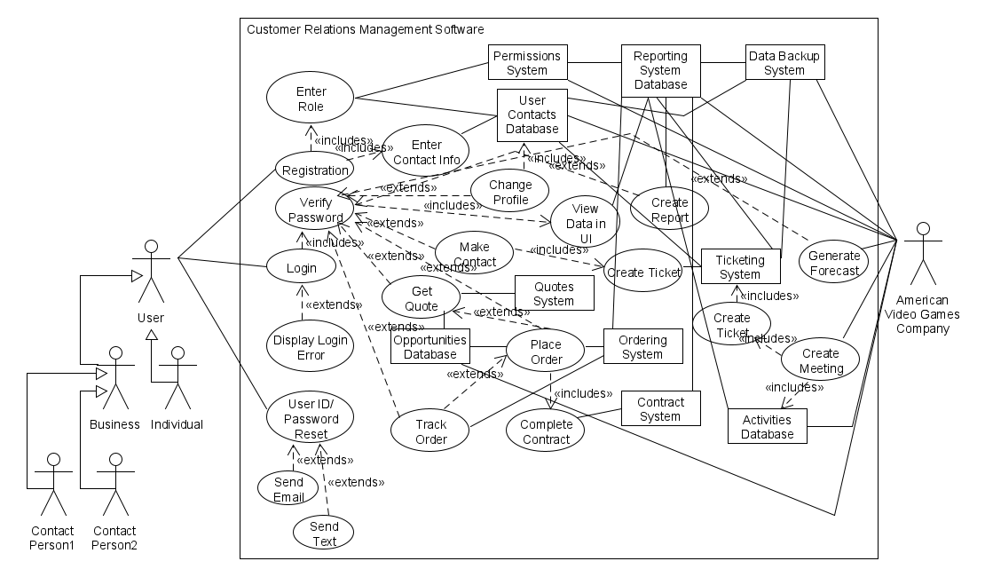

Figure 1: CRM Use Case Diagram

# Graphical user interface

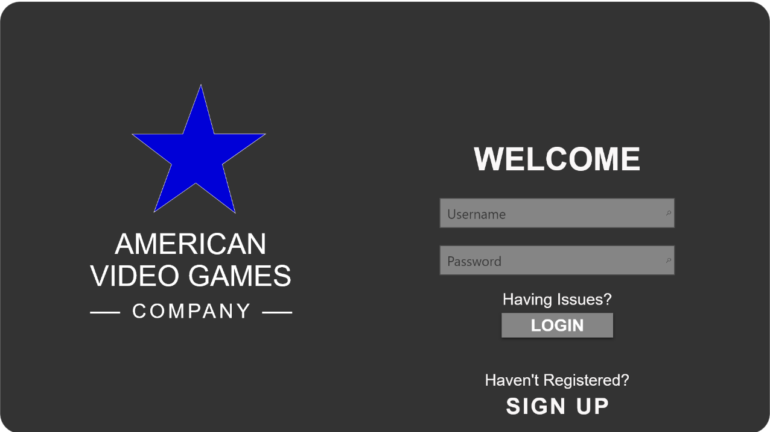

**2**

**4**

**7**

**3**

**1**

**6**

**5**

**8**

Figure 3: Sample GUI Mock-up

|  |  |  |  |
| --- | --- | --- | --- |
| GUI Control Mapping | | | |
| ID | Control | Property | Data Source |
| 1 | Graphic | On application open text = “AMERICAN VIDEO GAMES COMPANY” or null | NA |
| 2 | Textbox | On application open text = “Welcome” or null | NA |
| 3 | Textbox | Button text = “”, user enters Username | Internal Variable |
| 4 | Textbox | Button text = “”, user enters Password | Internal Variable |
| 5 | Link | On click change screen to Forgotten Username/Password Screen | NA |
| 6 | Button | On click change screen to User-Specific Interface | NA |
| 7 | Textbox | On application open text = “Haven’t Registered?” or null | NA |
| 8 | Link | On click change screen to Registration Screen | NA |

# Testing

To properly test the CRM software, we will test the functionality of the following system components:

● From quote to order placement functionality

● Role-based permissions restraints

● Creation of a communication that triggers ticketing system

# QUOTE & ORDER COMPONENT TESTING

The Quote to Order Placement Conversion Test verifies that the requirement of converting quotes to orders as specified by American Video Games Company’s order management criteria is functioning properly.

# QUOTE TO ORDER PLACEMENT CONVERSION TEST

## FUNCTIONAL TESTING

|  |
| --- |
| **Requirement to be tested**  Converting a quote into an order |
| **Preconditions: Conditions that must be present before test case can successfully run**  There will need to be a user interface for the quoting and ordering system. A user account should already be created with a user interface that links to the quoting user interface and the ordering user interface. A common database should already be configured with separate tables for quotes and orders. These two tables should be linked to allow the retrieval of a quote for processing of an order. |
| Steps: The steps the tester must execute to test the feature.   1. The pre-registered user should login with their username and password. 2. Once the user’s user interface appears, the user should click on the button to access the quoting system. 3. Once the quoting system user interface appears, the user should input their information and the product information into the fields in order to generate a quote. 4. The user should exit out of the quoting system, reentering the beginning user interface. 5. The user should click on the button to access the ordering system. 6. The user should click on the quote retrieval button to access the list of quotes in the Quotes table of the database. 7. The user should select the quote previously generated, select the quantity, and click add to order. 8. The user should fill out all remaining fields and click submit in order to place an order. 9. The user should access their email and verify that an order confirmation email was received and that the order details were correct. 10. The database administrator or other authorized personnel should examine both the Quotes and Orders table to verify that the input was placed in the database correctly (a query will suffice). |
| **Expected results: Expected results and any side effects such as updating a database, writing to a file, etc.**  The expected result should be an order placed within the Orders table with information prepopulated from the Quotes table. |
| **Pass/Fail: Mark whether the test case passed or failed. The results can be compiled and used to determine if the application is ready for delivery/release.**  Passed |

# PERMISSIONS TESTING

The Role-Based Permissions Test verifies that the requirement of performing a “hard delete” that is restricted to specific roles/permissions as specified by American Video Games Company’s general requirements criteria is functioning properly.

# ROLE-BASED PERMISSIONS TESTING

## Functional testing

|  |
| --- |
| **Requirement to be tested**  Permissions for a user with a managerial role and a user with a non-managerial role by attempting to perform a “hard delete” |
| **Preconditions: Conditions that must be present before test case can successfully run**  There will need to be user interfaces in place for a managerial user account and a non-managerial user account. Permissions . A relational database should already be configured with execute permissions allowed for the delUser() method only for managerial roles only. For non-managerial roles, the execute permissions for the delUser() method should not be permitted. “Dummy” information should be prepared for both a managerial user account and a non-managerial user account. A pre-created user account with inaccurate information should be created beforehand for deletion purposes (User ID 904) and verified that it was created successfully by querying the Users table in the database. |
| **Steps: The steps the tester must execute to test the feature.**   1. The user should press the ‘SIGN UP’ link on the login user interface. 2. The prepared “dummy” information should be submitted for the registration of a new non-managerial user account. 3. Repeat the two previous steps for the registration of a new managerial user account. 4. The user should login to the non-managerial user account. 5. Since non-managerial accounts don’t have access to a Delete User button, press Alt-C at the user interface to access the command line interface. 6. At the prompt, the user should type delUser(904) to attempt to delete the user account previously created for deletion. 7. The database administrator or other authorized personnel should examine the Users table to verify that the user account with the User ID 904 was not deleted (a query will suffice). 8. Next, the user should login to the managerial user account. 9. Since managerial accounts have access to a Delete User button, attempt to delete the user account previously created (User ID 904). 10. A pop-up window should prompt the user to click ‘OK’ in order to confirm that the user wishes to delete the user account. The user should click ‘OK’. 11. The database administrator or other authorized personnel should examine the Users table to verify that the user account with the User ID 904 was deleted (a query will suffice). |
| **Expected results: Expected results and any side effects such as updating a database, writing to a file, etc.**  The expected results are the failure of deletion of the pre-created user account with the User ID 904 by the non-managerial account user and the successful deletion of the user account by the managerial account user. |
| **Pass/Fail: Mark whether the test case passed or failed. The results can be compiled and used to determine if the application is ready for delivery/release.**  Passed |

# communicationS TESTING

The Communication-Triggered Ticket Event Test verifies that the requirement of having a ticket created for every communication with contacts as specified by American Video Games Company’s contact management criteria is functioning properly.

# communication-triggered ticket event TESTING

## Functional testing

|  |
| --- |
| **Requirement to be tested**  Making a phone call to a company salesperson that results in the creation of a ticket into the ticketing system |
| **Preconditions: Conditions that must be present before test case can successfully run**  Prepared false contact information for a company and a reason for contact should be ready before a call is made. There will need to be a user interface for the login, salesperson, contacts system, and ticketing system already created. A user account with a salesperson role should already be created with a salesperson user interface that links to the contacts user interface and the ticketing user interface. A common database should already be configured with separate tables for users, contacts, and tickets. These tables should be linked to allow interaction between the systems and the users. |
| **Steps: The steps the tester must execute to test the feature.**   1. The tester should place a call to the company’s sales department, using the previously prepared information for reference. 2. After logging in to their account, the salesperson should create a contact by accessing the Contacts interface by pressing the ‘Contacts’ button on their user interface and selecting ‘Create Contact’ in the Contacts interface. 3. The salesperson should then select the user from the list provided on the Contacts interface screen and press the ‘Create Ticket’ button. 4. Since a timestamp is created automatically when the ‘Create Ticket’ button is pressed, the salesperson should fill out the remaining unpopulated fields and press ‘Save’. 5. The tester should end the call. 6. The database administrator or other authorized personnel should examine both the Tickets and Contacts tables to verify that the input was placed in the database correctly and that a ticket was created successfully (a query will suffice). |
| **Expected results: Expected results and any side effects such as updating a database, writing to a file, etc.**  The expected result is that a ticket will be created in the Tickets table of the database with correctly recorded fields. |
| **Pass/Fail: Mark whether the test case passed or failed. The results can be compiled and used to determine if the application is ready for delivery/release.**  Passed |

# Sources

*https://www.guru99.com/waterfall-vs-agile.html*